Capteur SRF08

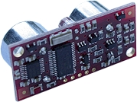

Ce module, idéalement conçu pour les applications de télémétrie pour robotique est capable de déterminer la distance qui le sépare d'un obstacle se présentant devant lui (entre 3 cm et 6 m).
Il s'interface à l'aide de son bus I2C™ .
Il comporte aussi un un capteur de lumiere aussi.
Caractéristiques techniques:
- Alimentation: + 5 Vcc.
- Consommation: 15 mA env. - 3 mA (au repos).
- Angle de détection: 55 ° env.
- Fréquence: 40 kHz
- Portée de mesure: de 3 cm à 6 m (réglable)
-Unité de mesure: mm, pouces ou µs
- Gain variable .
brochage :
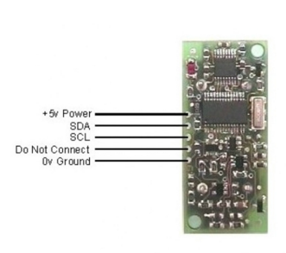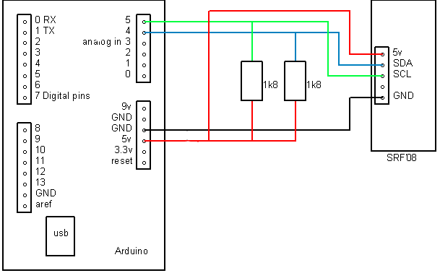
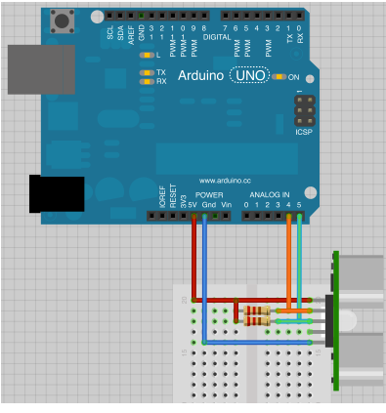
Datasheet :https://www.cs.york.ac.uk/micromouse/Docs/SRF08UltraSonicRanger.pdf

#include<Wire.h>

void setup(){
Wire.begin();
//I2c bus
Serial.begin(115200);
delay(100);
}
void loop(){
int distance=getDistance();
Serial.print("Distance:");
Serial.print(distance);
Serial.print("cm");
delay(100);
}

int getDistance() //fonction retourant la distance
{
int reading=0;

// step 1: instruct sensor to read echoes
Wire.beginTransmission(112); // transmit to device #112 (0x70)
// the address specified in the datasheet is 224 (0xE0)
// but i2c adressing uses the high 7 bits so it's 112
Wire.write(byte(0x00)); // sets register pointer to the command register (0x00)
Wire.write(byte(0x51)); // command sensor to measure in "centimeters" (0x51)
// use 0x50 for inches
// use 0x52 for ping microseconds
Wire.endTransmission(); // stop transmitting

// step 2: wait for readings to happen
delay(70); // datasheet suggests at least 65 milliseconds

// step 3: instruct sensor to return a particular echo reading
Wire.beginTransmission(112); // transmit to device #112
Wire.write(byte(0x02)); // sets register pointer to the first echo register (0x02)
Wire.endTransmission(); // stop transmitting

// step 4: request reading from sensor
Wire.requestFrom(112, 2); // request 2 bytes from slave device #112

// step 5: receive reading from sensor
if (2 <= Wire.available()) { // if two bytes were received
reading = Wire.read(); // receive high byte (overwrites previous reading)
reading = reading << 8; // shift high byte to be high 8 bits
reading |= Wire.read(); // receive low byte as lower 8 bits
return(reading);
//or
//byte highByte = Wire.read(); // Get high byte
//byte lowByte = Wire.read(); // Get low byte

// reading= (highByte << 8) + lowByte;
}
}

